CLOUDS: A Surface Exodus
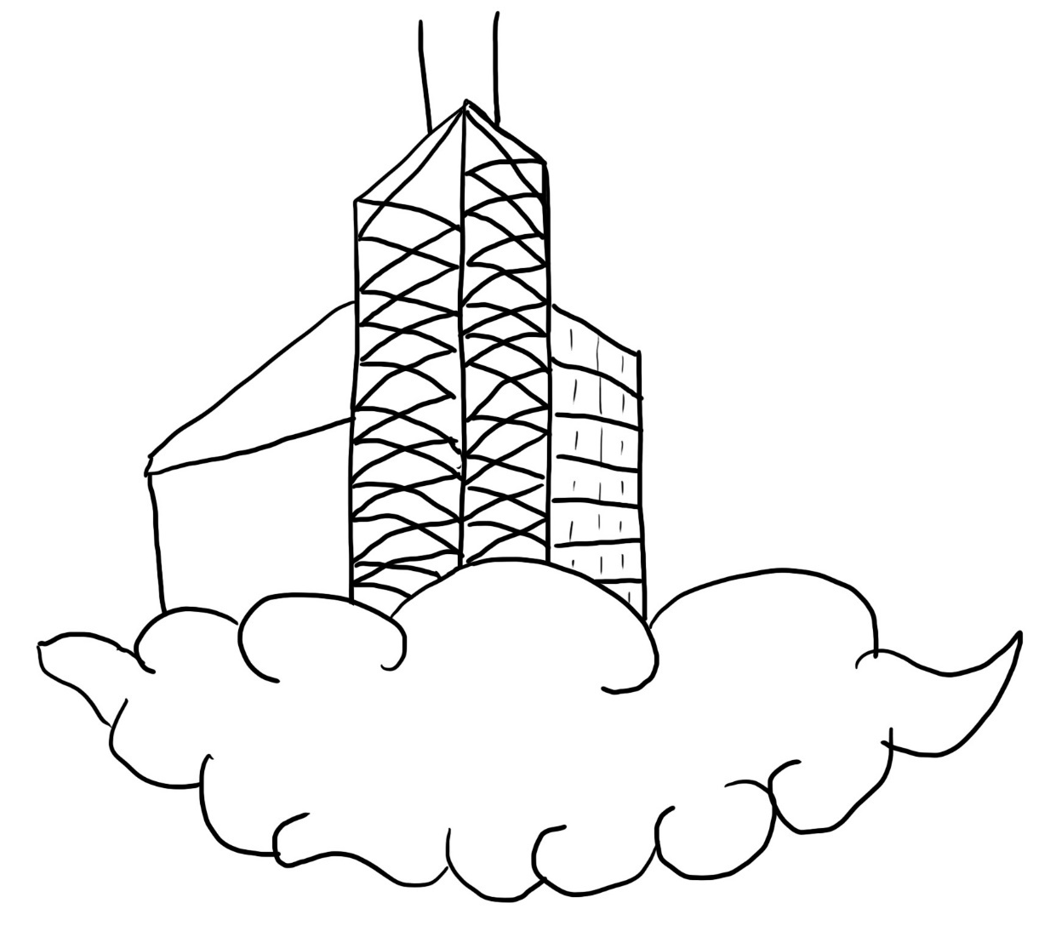
Drawn by: Roberto A. Ramirez
Welcome to CLOUDS! We are working every day to help create the best future for humanity. We have made progress on inhabiting the skies with our new clouds system. If you would like, there are plenty of areas here for you to explore. Come see the progress we have currently. Or learn more about us and our goals. Check out our merchandising. View what would seem similar and different in this new world. And if you want to be a part of history, we are always looking for new recruits to help us float our way into the future.

Who We Are
If you are unaware, CLOUDS, also known as Concentrated Lumps of Unaging Durable Surfaces, is a Company founded by our CEO, Jon Carter. Our goal is to create a giant mass of concentrated clouds so that humans and all other lives can venture and inhabit the skies. We have a vision of seeing cities floating in the sky and entire neighborhoods or even countries to allow for more surface area for people to live.
The company was kickstarted in the house of Jon Carter. Starting as a young entrepreneur, Jon Carter had garnered enough support through his work and deals to create his company. After 6 years of experience in the business world, Jon Carter finally decided to pursue his life long dream of inhabiting the skies.
4 years, 20 backing countries, and billions of supporters later, CLOUDS is now one of the largest companies on the planet. CLOUDS lives and breathes to creating these concentrated clouds and use their efforts to make the world a better place.
For The Lives of Everyone
As we work on our endeavors, we do so in memory of everyone who hadn’t gotten the chance to see this new future. Especially, our hearts go out to the miners whose lives were lost in the tragic incident in Osei. We understand that most of the support we get is due to the looming threat of the unknown gas that was found during that tragic incident. We would be lying if we didn’t feel the pressure of the world as we work, but in a way, the same amount of positive support we have gotten from the masses work just as well to keep us motivated and work even harder.
Research
The hardest part about reaching our goal is the creation of these concentrated clouds. We have worked day in and day out to create these long lasting clouds following this guide. Our current solution to this problem is a new device we have created. Currently we call it project Skyward. We have created a mechanism that will keep our clouds everlasting. It’s design to control the temperature around it up to a radius of five miles. The device alone is able to hover in the air using strong turbines. Lastly it has a very powerful gravitational pull, using the valuable resource known as alomonium. It causes project Skyward to continuously spin in place, allowing itself to extrude enough gravitational force to maintain the shape of the clouds by keeping the water particles in the air very close together. This is how we have been able to create such dense clouds. The mixture of increasing the size of water particles, and condensing them in such small places allows for us to create a strong enough surface to be able to hold other solid structures on top of it. Currently, project Skyward seems to have a lifespan of about three years before needing a replacement. We will have to conduct a plan on how we are to go about replacing the devices when the time comes. Currently it seems safe enough to deploy the new device next to the old one to avoid any type of collapse with the cloud. We only hope this method continues to work as the devices become powerful in the future.
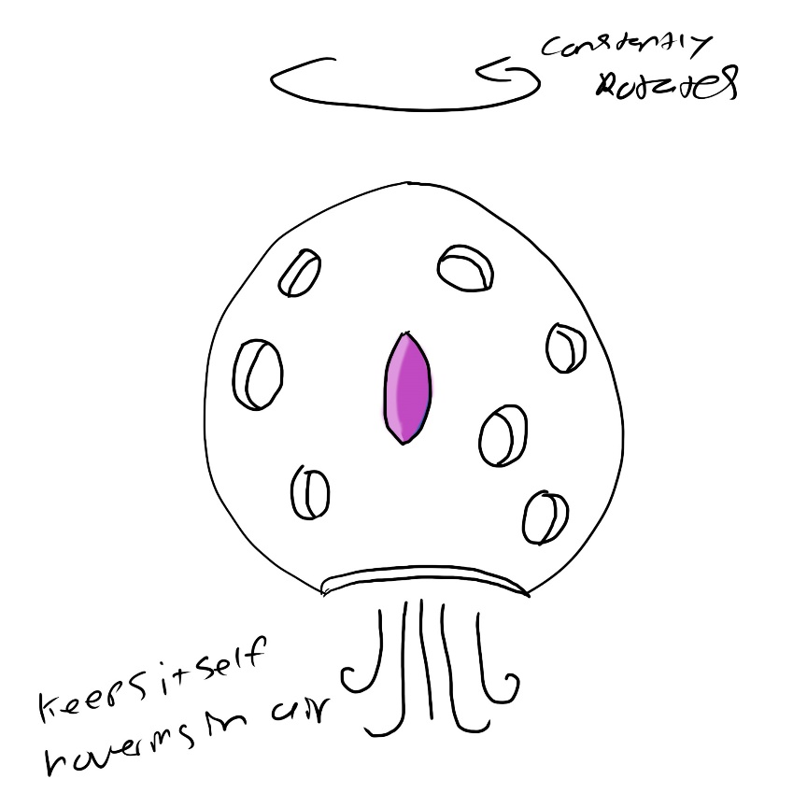
Drawn by: Roberto A. Ramirez
In order to obtain alomonium, we have decided to partner up with Pearl Mining Company. They have agreed to help us indefinitely and even in the future as we move to the skies. In preparation for that time, we have been working on a contraption to allow for travel in the air back down to the ground in a safely manner. The dangers we have with this travel is finding ways to keep the passengers safe during travel from the difference in air pressure, and what is the most efficient way to transport materials from the ground, up to thousands of feet in the air. We have been working on creating large vertical pipelines for transportation of materials. It is the quickest way to receive materials from the surface and does not require constant transportation of personnel to deliver. We will also be able to incorporate batching to help reduce the number of pipelines needed to make. When dealing with transportation of personnel, we have decided on making long shafts similar to elevators. We have incorporated many safety measures and pressure control in the elevator system. The elevator being made will have a current speed of traveling at 45mph. This will allow us to make sure our personnel don’t have to spend too much time traveling to the surface.
Lastly, we are aware that in due time, the entire surface of the planet will be covered in the unknown gas. We are working hand in hand with scientist from Bourne University who have been working nonstop since the incident in learning everything we can about the gas. What we have figured out are safety precautions we can take to avoid the gas entering the body. We are making special hazardous suits to protect the entire body from letting any gas in. We also have the highest graded masks to allow protection from outside air, while being connected to an oxygen tank to allow them to breath and for an estimated 8 hours so they can perform their shift uninterrupted. The gas at it’s lowest level has a density of around 3 kg/cubic meter. This isn’t that dangerous with the equipment provided. There are however very dangerous levels where at it’s most dense, at least that recorded, has been around 13 kg/cubic meter. It is recommended for all personnel not to enter areas with a recorded density over 7 kg/cubic meter.
Come Join the Team!
If you would like to help out in the future of humanity, come in and join CLOUDS. Our industry is booming and the more help we can get, the better. Check out our open positions below!
Store
If you would like to support us in any other way, consider buying the CLOUDS mascot plushie for your personal use. If you would like to reserve yourself a piece of land in the future, look at our rates below and find the best one suited for you!
Thank you so much for spending your time to learn about CLOUDS and what our goals are for the future. We promise that this route will better humanity. And if in the future who knows. Maybe we can be able to inhabit more than just the skies and the surface. Maybe we can go even further beyond.

